PRESS RELEASE

COMMUNICATIONS AND MEDIA TEAM OF THE 43RD ASEAN SUMMIT 2023

No.126/SP/TKM-ASEAN2023/ENG/9/2023

2023 ASEAN Summit Witnesses Contribution of All

Jakarta, 11 September 2023 – Aside from Indonesia's accomplishment for its success as the host nation, the recent 43rd ASEAN Summit left behind a number of stories. The gala dinner event held for guests of state, for instance, tells a tale.

Apart from the performances of famous singers from Indonesia and stunning cultural performances, the stage background which utilized video mapping technology and was shot at the capital's skyscrapers became a topic of conversation . The dinner gathering was truly made great by the gorgeous and breath-taking venue.

It required a special treatment on the windows of the two Indonesian Stock Exchange (BEI) or IDX Tower buildings and the two Mandiri Tower buildings to turn them into massive screens. A form of coating that darkens the glass is applied to the structure. As a result, people inside the buildings could not see clearly through the glass windows.

Andjarsari, who works at the Mandiri Tower, testified, "We’re not allowed to turn on the lights on the day of the event." She claimed that the dark glass coating had been put in place about a week prior to the event. “So, it felt like it’s cloudy all the time.” Fortunately, the event was a success and received praise from those who present. "Well, let's say that’s our sacrifice for our country,” She laughed.

On the other hand, the positive impact of the summit was felt by hotel industries in Jakarta. The presence of state guests coupled with residents’ enthusiasm at the summit increased hotel occupancy rates to its peak, particularly in the Senayan area. All rooms were sold out. “Yes, this week our rooms are fully occupied. We couldn’t even fulfil more requests for extra beds," said a receptionist at one of the hotels designated as the 43rd ASEAN Summit official hotels. The hotel, in fact, provided a designated shuttle drop-off/pickup point given the substantial number of conference attendees staying there.

On the other hand, fitness businesses were not particularly that fortunate. Only a few new members signed up during the conference week, according to a manager of a chain sports and fitness centers with outlets located along Jalan Sudirman, Jalan Thamrin, and Jalan Gatot Subroto. He admitted that he had to boost sales via phone.

However, he is aware that this condition is only temporary. “Moreover, this is related to the state interest. We have no choice," he said.

Understanding the impact the summit will have on community activities, the DKI Jakarta Provincial Government has issued an appeal to curtail activities in the city center days prior to the event. The group of state guests passing by during the conference week would affect the flow of traffic in Jakarta's core.

This condition had been anticipated by Agnes Aninditya, CEO of Hepi Inc. The location of her office which is near the conference venue is very prone to traffic jams. Since many employees live far from the office, the commute to and from work would be challenging for some. “I'm going to follow the local government’s suggestion to work from home”. She explained, "We changed the meeting timetable, or we held it online. After all, everything is done for the sake of the nation, for a greater interest,” concluded Agnes.

Nayla, a bank employee who works around the Senayan area, had the same mindset. “I applied for block leave as soon as I learned there would be a summit. So, I can go home to Solo. It’s all good. I would not be experiencing traffic jams,” she said.
Cahyo, on the other hand, who works at SCBD, is genuinely pleased. He laughed and added, "If this happened more often, I'll be happy." He suggested that local governments be firmer in forcing companies to let employees work from home. “This week has gotten more challenging for those who must commute,” he claimed. "I understand that this is to support the government."

The Indonesian people may be proud because their government has successfully organised the 43rd ASEAN Summit. Jakarta residents may have swelled in pride because they have all contributed, big or small, to make this international event a success.

***

For more information, please contact:
Director General of Public Information and Communications of the Ministry of Communications and Informatics – Usman Kansong (0816785320).

Get more information at http://asean2023.id, https://infopublik.id/kategori/asean-2023, and https://indonesia.go.id/kategori/ragam-asean-2023

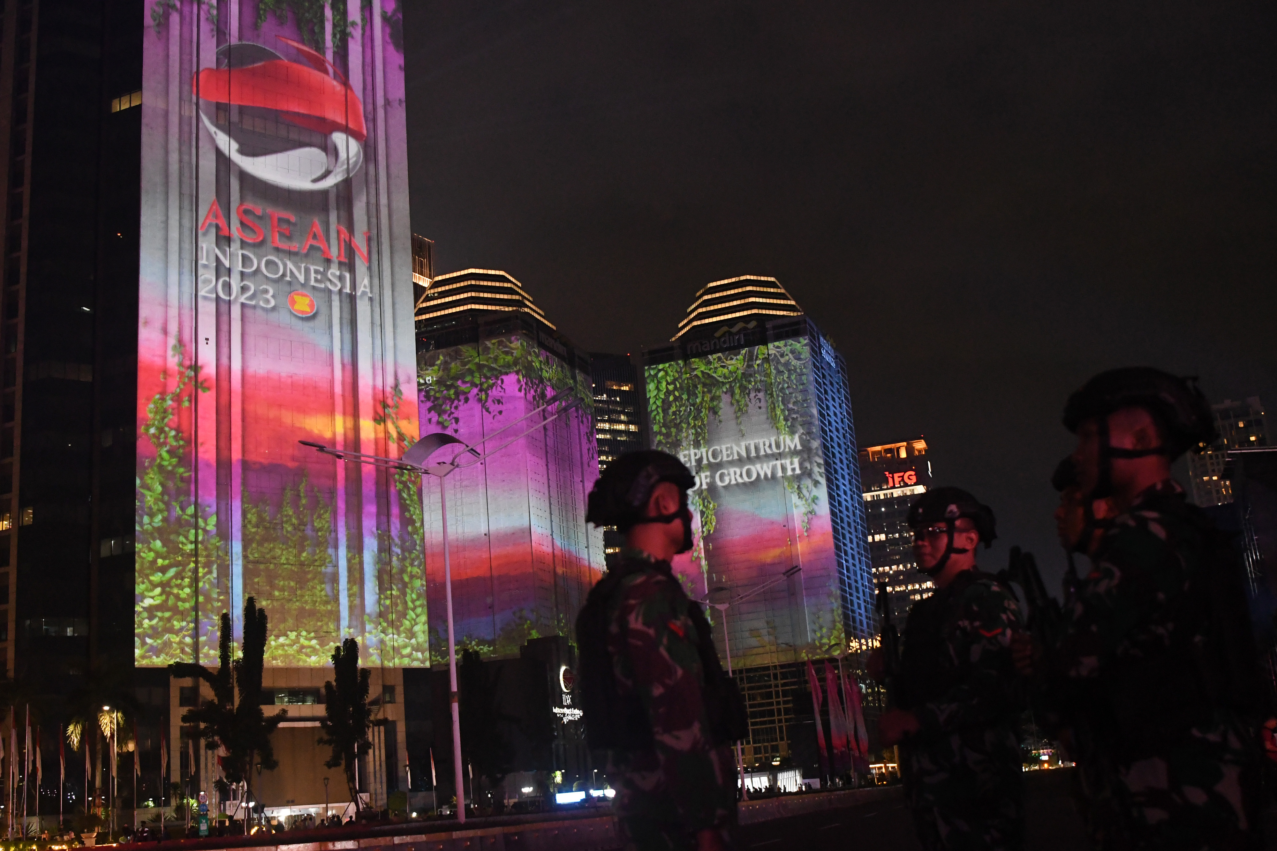
Indonesian National Armed Forces (TNI) personnel stand guard against the background of a video mapping performance during the Gala Dinner of the 43rd ASEAN Summit 2023 in Senayan, Jakarta, on Wednesday (6 September 2023). 2023 ASEAN Summit Media Center/Dhoni Setiawan/aww


Spectators watch a video mapping performance during the Gala Dinner of the 43rd ASEAN Summit 2023 in Senayan, Jakarta, on Wednesday (6 September 2023). 2023 ASEAN Summit Media Center/Dhoni Setiawan/aww.

